Press release

23 July 2025

Payments statistics: second half of 2024

* [Total number of non-cash payments in the euro area](https://data.ecb.europa.eu/search-results?searchTerm=PAY.H.U2.W0.TOTL1.1._Z.N.PN%20OR%20PAY.H.U2.W0.TOTL1.1._Z.G1.PN) in second half of 2024 increased by 8.6% to 77.6 billion compared with second half of 2023, with [total value](https://data.ecb.europa.eu/search-results?searchTerm=PAY.H.U2.W0.TOTL1.1._Z.N.EUR%20OR%20PAY.H.U2.W0.TOTL1.1._Z.G1.EUR) rising by 3.8% to €116.9 trillion
* [Card payments](https://data.ecb.europa.eu/data/datasets/PAY/PAY.H.U2.W0.CP0.1._Z.N.PN_R_TT) accounted for 57% of total number of non-cash payments in second half of 2024, [credit transfers](https://data.ecb.europa.eu/data/datasets/PAY/PAY.H.U2.W0.CT0.1._Z.N.PN_R_TT) for 21%, [direct debits](https://data.ecb.europa.eu/data/datasets/PAY/PAY.H.U2.W0.DD.2._Z.N.PN_R_TT) for 15% and [e-money payments](https://data.ecb.europa.eu/data/datasets/PAY/PAY.H.U2.W0.EMP0.1._Z.N.PN_R_TT) for 6%[1]
* [Number of contactless card payments](https://data.ecb.europa.eu/search-results?searchTerm=PCP.H.U2.W0.W0.CP1.1.2223.NR.PCS_ALL._Z._X._Z.N.PN%20or%20PCP.H.U2.W0.W0.CP1.1.2223.NR.PCS_ALL._Z._X._Z.G1.PN) in second half of 2024 increased by 15.5% to 29.5 billion compared with second half of 2023, with [total value](https://data.ecb.europa.eu/search-results?searchTerm=PCP.H.U2.W0.W0.CP1.1.2223.NR.PCS_ALL._Z._X._Z.N.EUR%20or%20PCP.H.U2.W0.W0.CP1.1.2223.NR.PCS_ALL._Z._X._Z.G1.EUR) rising by 15.1% to €0.8 trillion
* [Number of payment cards in circulation](https://data.ecb.europa.eu/search-results?searchTerm=PCN.H.U2.PCS_ALL.1.PN%20or%20PCN.H.U2.PCS_ALL.1.PCCH) at the end of second half of 2024 increased by 8.2% to 750.0 million compared with second half of 2023, averaging 2.1 [payment cards per euro area inhabitant](https://data.ecb.europa.eu/data/datasets/PCN/PCN.H.U2.PCS_ALL.1.PN_R_POP), with an [average value](https://data.ecb.europa.eu/data/datasets/PAY/PAY.H.U2.W0.CP0.1._Z.N.EUR_R_PNT) of around €39 per card transaction
* Around 56.1 billion [transactions processed by retail payment systems in the euro area](https://data.ecb.europa.eu/search-results?searchTerm=%20PST.H._Z.W0.1._T._T.RPS_U2_ALL.N.*.Z01) in second half of 2024, worth €26.4 trillion

The European Central Bank (ECB) today published statistics on non-cash payments for the second half of 2024.[2] The statistics comprise indicators on access to and use of payment services, payment cards and payment terminals by the public, as well as volumes and values of transactions processed through retail and large-value payment systems. This press release focuses on developments in the euro area as a whole, while statistics are also published at country level for all euro area and most non-euro area EU member states. EU and euro area aggregates are also published.[3]

## Payment services[4]

In the second half of 2024, the total number of non-cash payment transactions[5] in the euro area increased by 8.6% to 77.6 billion compared with the second half of 2023, with the corresponding total value rising by 3.8% to €116.9 trillion. Card payments accounted for 57% of the total number of transactions, while credit transfers accounted for 21%, direct debits for 15% and e-money payments for 6%. The remaining 1% comprised cheques, money remittances and other payment services (see annex, Table 1).

**Chart 1**Use of the main payment services in the euro area

(number of transactions in billions, graph on the right-hand-side refers to half-yearly data)

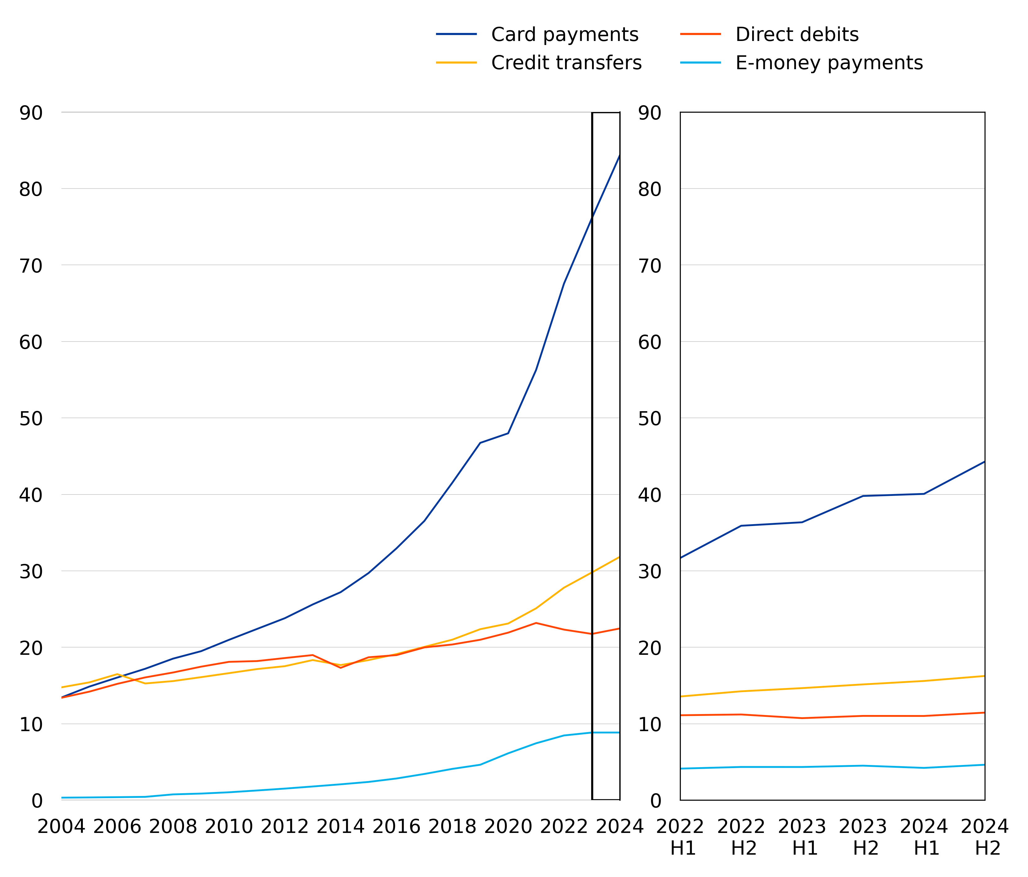

Source: ECB.  
Note: Data have been partially estimated for periods prior to 2010, as methodological changes were implemented in those years and some data are not directly available. The historical estimations done by the ECB ensure comparability of figures over the entire period. Statistics were also collected for cheques, money remittances and other payment services which together accounted for 1% of the total number of non-cash euro area payment transactions in the second half of 2024.

[Data on payment services](https://data.ecb.europa.eu/search-results?searchTerm=PAY.H.U2.W0.*._Z.N.PN%20OR%20PAY.H.U2.W0.*._Z.N.EUR)

### Card payments

In the second half of 2024 the number of card payments within the euro area increased by 11.3% to 44.3 billion compared with the second half of 2023. The corresponding total value of card payments rose by 9.4% to €1.7 trillion, reflecting an average value of around €39 per transaction. The split between remote and non-remote[6] transactions in the total number of card payments was 18% to 82%, while the split in terms of value was 28% to 72%. The number of contactless card payments initiated at a physical electronic funds transfer point of sale terminal increased by 15.5% to 29.5 billion compared with the second half of 2023, with the corresponding total value rising by 15.1% to €0.8 trillion. As a result, their share in the total number of non-remote card payments accounted for 81%, while the corresponding share in terms of value was 65%. At the national level, Lithuania continued to have the largest share of card payments as a percentage of the total number of non-cash payments in the second half of 2024, at around 79% (see annex, Table 2).

### Credit transfers[7]

In the second half of 2024 the number of credit transfers within the euro area increased by 7.3% to 16.2 billion compared with the second half of 2023, and the corresponding total value rose by 3.6% to €108.3 trillion. As higher-value payments are usually made by credit transfer[8], they accounted for 93% of the total value of non-cash payments. The ratio of transactions initiated electronically to those initiated using paper forms was around 16 to 1, while in terms of value the ratio was around 12 to 1. At the national level, Latvia continued to have the largest share of credit transfers as a percentage of the total number of non-cash payments in the second half of 2024, at around 36% (see annex, Table 2).

### Direct debits

In the second half of 2024 the number of direct debits within the euro area increased by 3.9% to 11.4 billion compared with the second half of 2023, and the corresponding total value rose by 8.2% to €5.4 trillion. Of the total number of direct debits, those with an electronic mandate accounted for 12% whereas those with consent given in other forms accounted for 88%, while in terms of value the split was 14% to 86%. At the national level, Germany continued to have the largest share of direct debits as a percentage of the total number of non-cash payments in the second half of 2024, at around 32% (see annex, Table 2).

### E-money payments

In the second half of 2024 the number of e-money payment transactions within the euro area increased by 2.6% to 4.6 billion compared with the second half of 2023, and the corresponding value rose by 15.8% to €0.3 trillion. Of the total number of e-money payment transactions, those made with e-money accounts accounted for 95% whereas those made with cards on which e-money can be stored accounted for 5%, while in terms of value the split was 93% to 7%.

## Cards and accepting devices

At the end of the second half of 2024 the number of cards with a payment function[9] had increased by 8.2% to 750.0 million compared with the number at the end of the second half of 2023. With a total euro area population of around 353 million, this implies an average of 2.1 payment cards per euro area inhabitant.

At the end of the second half of 2024 the total number of automated teller machines (ATMs) in the euro area had decreased by 3.1% to around 253.7 thousand compared with the number at the end of the second half of 2023. Of these, 33% accepted contactless transactions.

At the end of the second half of 2024 the total number of point of sale (POS) terminals had increased by 7.9% to around 20.7 million[10] compared with the corresponding number at the end of the second half of 2023. Of these terminals, 92% accepted contactless transactions.

## Payment systems[11]

### Retail payment systems

Retail payment systems located in the euro area handle mainly payments that are made by individuals and businesses, with a relatively low value and high volume overall.

In the second half of 2024, 34 retail payment systems within the euro area processed around 56.1 billion transactions with a combined value of €26.4 trillion. Instant credit transfers accounted for 16% of the total number and for 4% of the total value of credit transfer transactions processed by euro area retail payment systems.

Retail payment systems located in the euro area differ significantly in terms of type, size and geographical scope of transactions they process. The three largest systems (MCMS[12], STEP2-T[13] and CORE (France)) processed 65% of the volume and 62% of the value of all transactions processed by the retail payment systems located in the euro area in the second half of 2024.

**Chart 2**Main retail payment systems located in the euro area, values and numbers of transactions processed in the second half of 2024

(value of transactions in EUR trillions and number of transactions in billions)

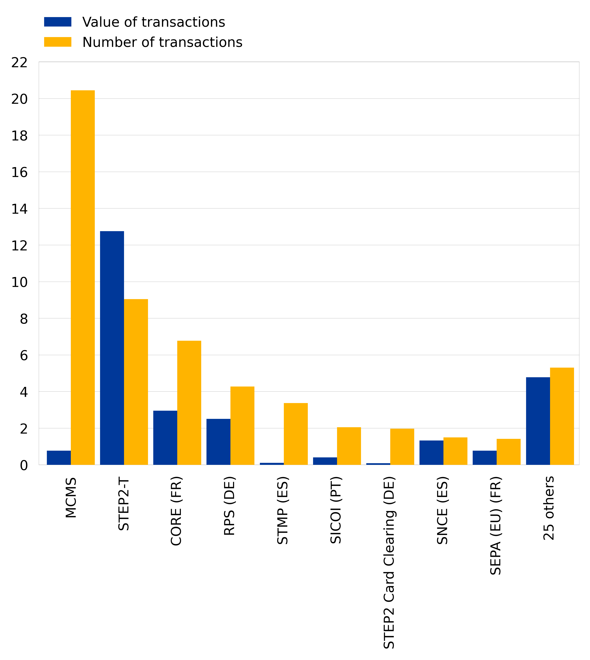

Source: ECB.

[Data on retail payment systems](https://data.ecb.europa.eu/search-results?searchTerm=%20PST.H.*.W0.1._T._T.RPS*.N.*.Z01%20OR%20PST.H.*.W0.1._T._T.STEP2*.N.*.Z01%20OR%20PST.H.*.W0.1._T._T.IRT1.N.*.Z01)

### Large-value payment systems

Large-value payment systems form the backbone of the euro area financial market infrastructure and are designed primarily to process large-value and/or high-priority payments made between system participants for their own account or on behalf of their customers.

In the second half of 2024, large-value payment systems located in the euro area settled 74.7 million payments with a total value of €223.7 trillion in euro payments, with T2 and EURO1/STEP1 being the two main systems.[14]

**Chart 3**Main large-value payment systems located in the euro area, values and numbers of transactions processed in the second half of 2024

(value of transactions in EUR trillions and number of transactions in millions)

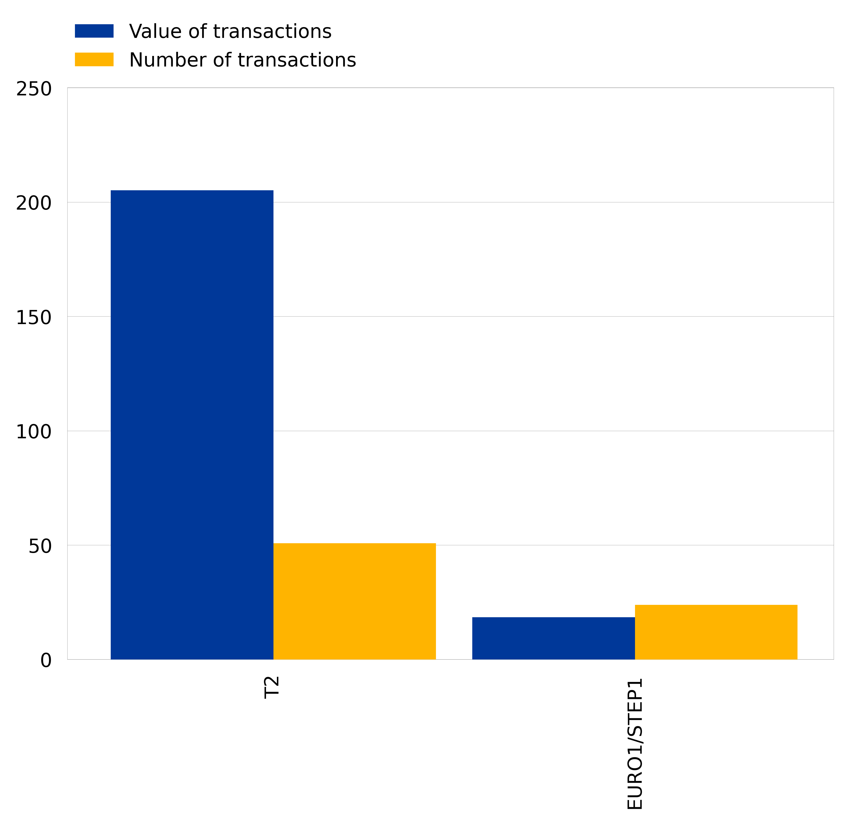

Source: ECB.

[Data on large-value payment systems](https://data.ecb.europa.eu/search-results?searchTerm=%20PST.H.FI.W0.1._T._T.LVPS_FI_1.N.*.Z01%20OR%20PST.H._Z.B0.1.CTDD._T.TRGT2.N.*.Z01%20OR%20PST.H._Z.W0.1._T._T.STEP1.N.*.Z01)

## Notes:

* The full set of payment statistics can be downloaded from the [ECB Data Portal](https://data.ecb.europa.eu/data/data-categories#payment-services-large-value-payment-systems-and-retail-payment-systems) (EDP). The EDP also includes [interactive dashboards](https://data.ecb.europa.eu/data/datasets/PAY/dashboard) and [interactive reports](https://data.ecb.europa.eu/publications/payments-statistics/3075435) supporting data visualization. Detailed methodological information, including a list of all data definitions, is available under “Payment services and large-value and retail payment systems” in the "[Statistics](https://www.ecb.europa.eu/stats/payment_statistics/payment_services/html/index.en.html)" section of the ECB's website.
* As of 2025, the dissemination scope of payments statistics in the EDP has been extended in two-waves. Since March 2025, the quarterly publication of payments statistics has been significantly widened, offering more detailed geographical breakdowns as well as additional details on card payments per type of merchant category codes (MCC). As of July 2025, the semi-annual publication includes details on the payment schemes for credit transfers and direct debits as well as more granular geographical breakdowns, among others. In addition, some indicators related to fraudulent payment transactions are now publicly available in the EDP. For the latter, please also refer to the relevant disclaimer available towards the bottom of the [EDP page](https://data.ecb.europa.eu/methodology/payment-services-large-value-payment-systems-and-retail-payment-systems).
* Taking effect on 1 January 2022, the methodological and reporting framework for payments statistics was enhanced to take progressive developments in the payments market and related changes in the legal framework in Europe into account. The enhanced reporting requirements are set out in Regulation ECB/2020/59 amending Regulation ECB/2013/43 on payments statistics and in Guideline ECB/2021/13 on reporting requirements on payments statistics. In addition, the Manual on payments statistics reporting is available on the [ECB’s website](https://www.ecb.europa.eu/stats/payment_statistics/payment_services/shared/pdf/manual_payments_statistics_reporting.xlsx).
* Hyperlinks in the main body of the press release and in annex tables lead to data that may change with subsequent releases as a result of revisions. Figures shown in annex tables are a snapshot of the data at the time of the current release. Unless otherwise indicated, statistics referring to the euro area cover the EU Member States that had adopted the euro at the time to which the data relate.

1. Statistics are also collected for cheques, money remittances and other payment services, which together accounted for around 1% of the total number and for 1% of the total value of non-cash euro area payment transactions in the second half of 2024.
2. The published data have been collected in accordance with Regulation ECB/2020/59 amending Regulation ECB/2013/43 on payments statistics, which came into effect on 1 January 2022. Regulation ECB/2020/59 increased the frequency of data collection from annual to semi-annual. Data for some high-level indicators as well as additional details on card payments are collected with quarterly frequency. Data for the second half of 2024 are flagged as provisional and may be subject to revisions.
3. At the time of reporting the semi-annual data for the second half of 2024, some non-euro area EU countries were still in the process of implementing the requirements of Regulation ECB/2020/59. As such, EU aggregates do not cover all EU countries. Further information on which EU countries are reporting partial scope can be found in the country-specific methodological notes on the [ECB Data Portal](https://data.ecb.europa.eu/sites/default/files/2025-01/Payment%20statistics%20%E2%80%93%20methodological%20notes.pdf).
4. SEPA instruments are included in the respective categories. Information on these instruments can be found [on the ECB's website](https://www.ecb.europa.eu/paym/integration/retail/html/index.en.html).
5. Total non-cash payment services exclude cash-withdrawals and include credit transfers, direct debits, card payments with cards issued by resident payment service providers, e-money payment transactions with e-money issued by resident payment service providers, cheques, money remittances and other payment services. A wider [total](https://data.ecb.europa.eu/search-results?searchTerm=PAY.H.U2.W0.TOTL.1._Z.N.PN%20OR%20%20PAY.H.U2.W0.TOTL.1._Z.N.EUR) that includes cash withdrawals is also available on the ECB Data Portal.
6. Remote card payments are payment transactions initiated using the internet or a device that can be used for distance communication, whereas non-remote card payments are initiated at terminals, including those using contactless technology.
7. Credit transfers also include SEPA instant credit transfers.
8. The ECB payments statistics on credit transfers involving non-monetary financial institutions also include those between corporations and other business entities, which significantly contribute to the high value of the total credit transfers in the euro area.
9. Cards with a payment function exclude cards having only an e-money function.
10. Due to multi-acquiring of card accepting devices, the number of ATM and/or POS terminals is affected by double counting in some euro area countries. This has been flagged in the [country-specific methodological notes](https://data.ecb.europa.eu/publications/payments-statistics/3075435) of the affected countries. The concept of multi-acquiring refers to a business case where more than one payment service provider acquires transactions at the same card accepting device.
11. Some of the payment systems mentioned in this press release are systemically important payment systems at euro area level. More information can be found on the [ECB's website](https://www.ecb.europa.eu/paym/pol/activ/systems/html/index.en.html).
12. The Mastercard Clearing Management System (MCMS) is a payment system for processing transactions in euro and other currencies. It is operated by Mastercard Europe in Belgium with participants in more than 50 countries and territories.
13. STEP2 is a pan-European automated clearing house for retail payments in euro operated by EBA CLEARING.
14. T2 is the Eurosystem’s real-time gross settlement service that settles euro payments in central bank money. From a legal point of view, T2 is part of the consolidated TARGET Services platform, which replaced the pre-existing TARGET2 RTGS system operated by the Eurosystem until March 2023. EURO1/STEP1 is an EU-wide multilateral net large-value payment system for euro payments operated by EBA CLEARING. Payments are processed in EURO1/STEP1 throughout the day and final balances are settled at the end of the day in T2.